**Online Examination System UML Diagrams**



*Prepared by:*

1) Dalia Mansour Fathi Hallabo

2) Malek Mohamed Adel Wanas

3) Habeba Hossam Mahmoud ElHabashy

4) Hadeel Awad AbdelAziz Khattab

5) Joud Mahmoud Youssef

# UseCase Diagram

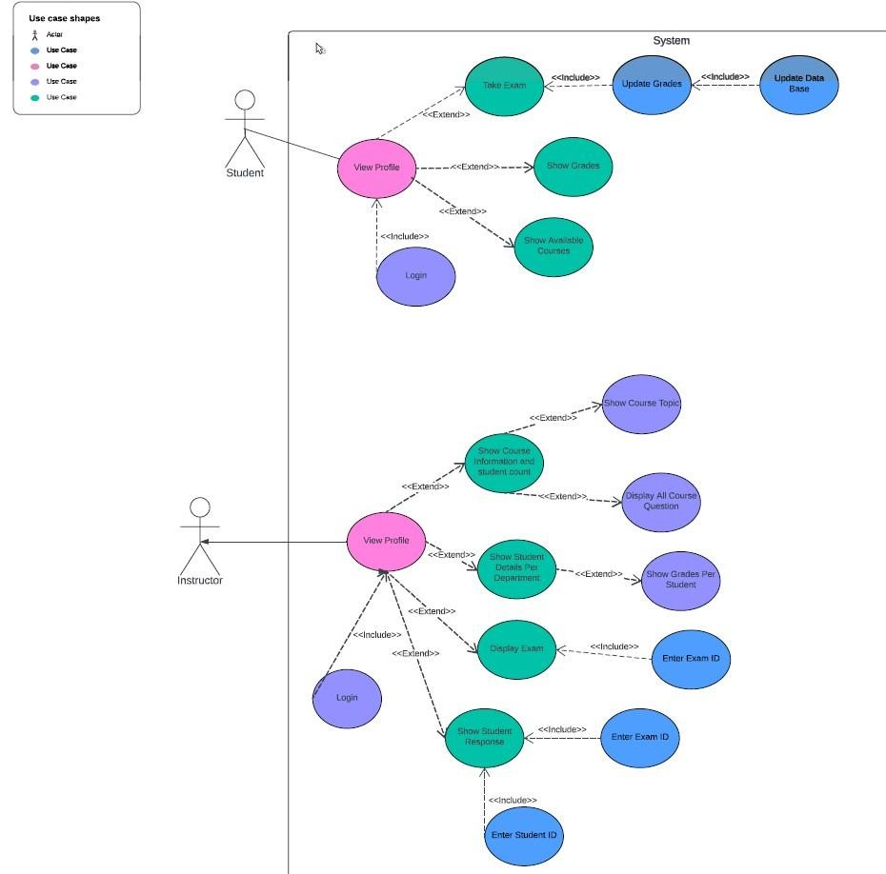

# UseCase Diagram – Tables

|  |  |
| --- | --- |
| Name | Take Exam |
| Description | Student takes course exam dependent on his department |
| Actors | Student, System |
| Assumption | Student is enrolled in department and registered in the system [database] |
| Outcome | Student takes his courses exams and  receives his grades |
| Actor | System |
| 1-student logs into the system      3-student’s profile appears with his department’s courses | 2-system checks the email and password  if it’s saved in the data base |
| Alternative 1 after step 2  If the email or password is incorrect, the system prompts the student to reenter. | |
| 4-student selects the course’s  exam he wants to take      6-student solves the exam’s questions  7-student submits his response | 5-system generates an exam with  random questions for each student      8-system takes student responses and saves them in the database  9- system compares his answers with the correct answers saved in database 10system shows student’s grade and  save it in the database |

|  |  |
| --- | --- |
| Name | Show Student Details Per Department |
| Description | Instructor checks student details based on courses he teaches |
| Actors | Instructor, System |
| Assumption | Instructor is registered in the database with courses he teaches |
| Outcome | Instructor checks student details and his grades on the courses he gives |
| Actor | System |
| 1-Instructor logs into the system      3-Instructor’s profile appears with courses he teaches | 2-system checks the email and  password if it’s saved in the data base |
| Alternative 1 after step 2  If the email or password is incorrect, the system prompts the instructor to re-enter. | |
| 4- Instructor selects to show student details for each  department      6-Instructor selects to view student grades | 5-system shows all student details  related to all courses in each  department      7- system shows all grades for each student in each course |

|  |  |
| --- | --- |
| Name | Show Student Response |
| Description | Instructor checks student’s exam questions with responses |
| Actors | Instructor, System |
| Assumption | Instructor is registered in the database with courses he teaches |
| Outcome | Instructor checks student’s answers |
| Actor | System |
| 1-Instructor logs into the system      3-Instructor’s profile appears with courses he teaches | 2-system check the email and password if it’s saved in the data base |
| Alternative 1 after step 2  If the email or password is incorrect, the system prompts the instructor to re-enter. | |
| 4- Instructor enters exam id and student id | 5-system shows exam’s questions with  student’s answer |
| Alternative 2 after step 4  If the exam id or student id is incorrect, the system prompts the instructor to re-enter. | |

# Class Diagram

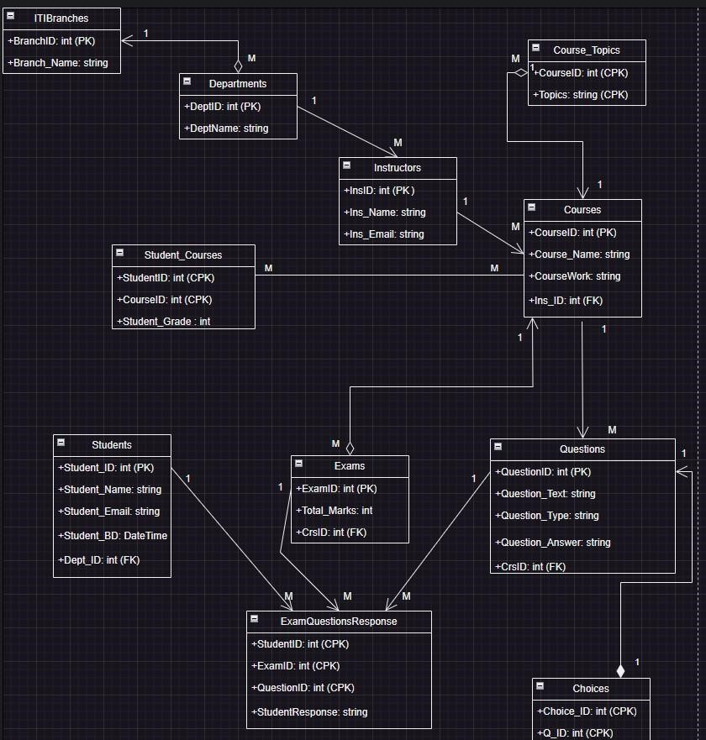

# Student-Activity Diagram

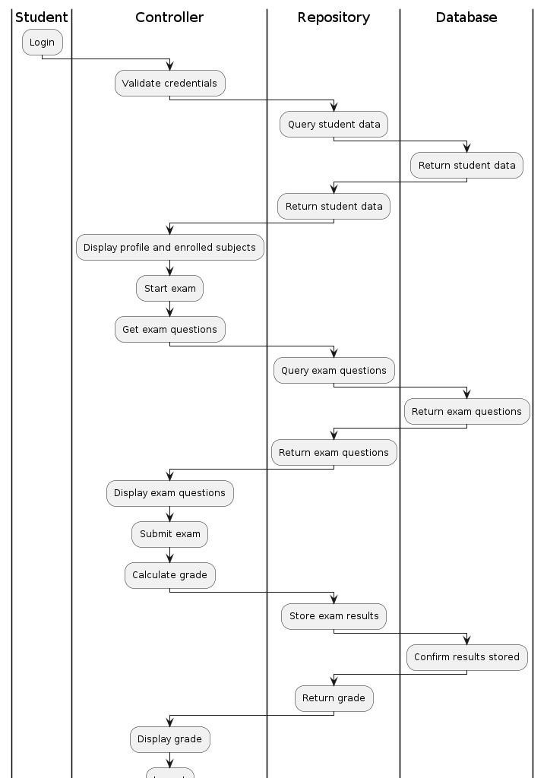

# Instructor-Activity Diagram

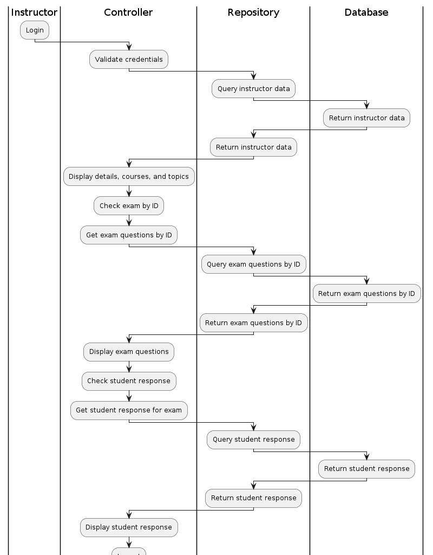

# Student – Sequence Diagram

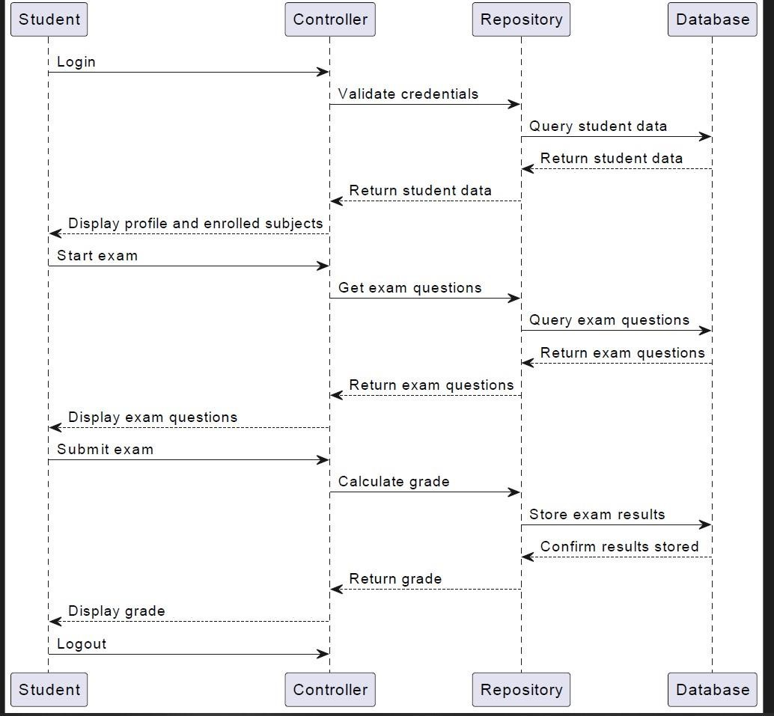

# Instructor – Sequence Diagram

